Currículum Vitae

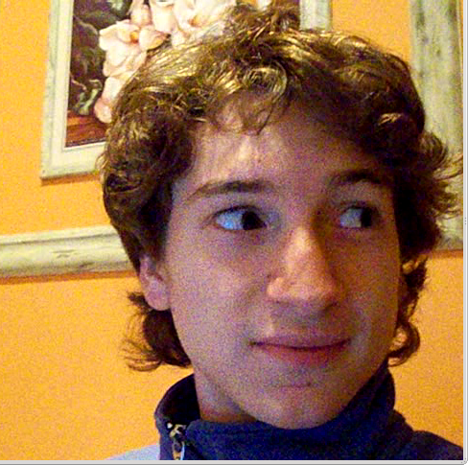
Marcos Ariel Chaparro

Personal information:

Nationality: Argentino
Place of birth: Puerto Belgrano, Buenos Aires, Argentina
Dato of birth: 28 August 1987.
D.N.I.: 33.120.528
Marital status: Single
Address: Martín García 184, Punta Alta, Buenos Aires
Telephone: [+549] 2932 492779 (mobile)
E-mail: marcus.chaparro@gmail.com

Education:

High School: “Bachiller con orientación Ciencias Naturales”, Inst. José M. Estrada – Punta Alta. 2005.
University: Electronic Engineering,at U.T.N. - Bahía Blanca. 26 courses passed

Skills

Electronics, Neural Networks, Linux and Windows.
C programming for microcontrollers ARM, Microchip PIC and dsPIC, and a bit of Freescale S12.
Qt4 framework.
Real time software (preempt-rt linux, Xenomai, MaRTe OS, CooCox) running in x86, ARM cortex and Microchip PIC16.
Design,pcb layout and low scale production of embedded systems.

Laboral experience:

2008-2009: Researcher for the “Grupo de Estudios de Bio-Ingeniería” (GEBI) in the Universidad Tecnológica Nacional.
2009-2010: Intern at the Hospital Naval Puerto Belgrano, repairing electromedical intruments and designing upgrades for the centrifuges of the lab.
2010-2011: Member of DIYEFI.org, designing hardware for the FreeEMS project, with many prototypes sold around the world. Also in charge of a GUI.

Languages:

Spanish, native fluency
English, poor fluency, good written practice.

Publications:

2010: Co-author of the paper “Herramienta Computacional Para la Determinación de Mapas Electromagnéticos de Radiofrecuencias.” N. Mata, P. Baldini, Ch. Galasso, M Chaparro, M Silva Bustos. Exposed at EMNUS 2010, UTN, FR Haedo.

Other activities:

2007: Development and testing of an Engine Management Sytem, intended to be an extremely cost-effective solution to replace carburetors.
2008: ACM-IBM international collegiate programming contest , representing the UTN FRBB at the Universidad de Buenos Aires.

